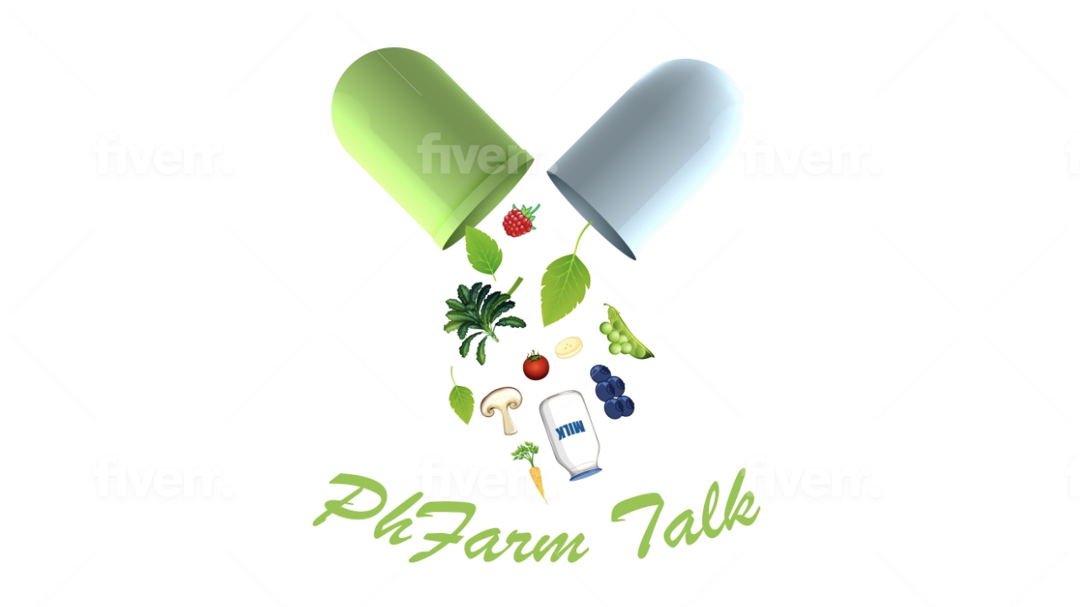

PhFarm Talk is a program designed to educate and discuss the benefits of food and medicine for the intervention, management and prevention, and treatment of illness and disease.
The program is delivered by in person and pre- recorded messages and discussion from Pharmacy interns and pharmacist.

