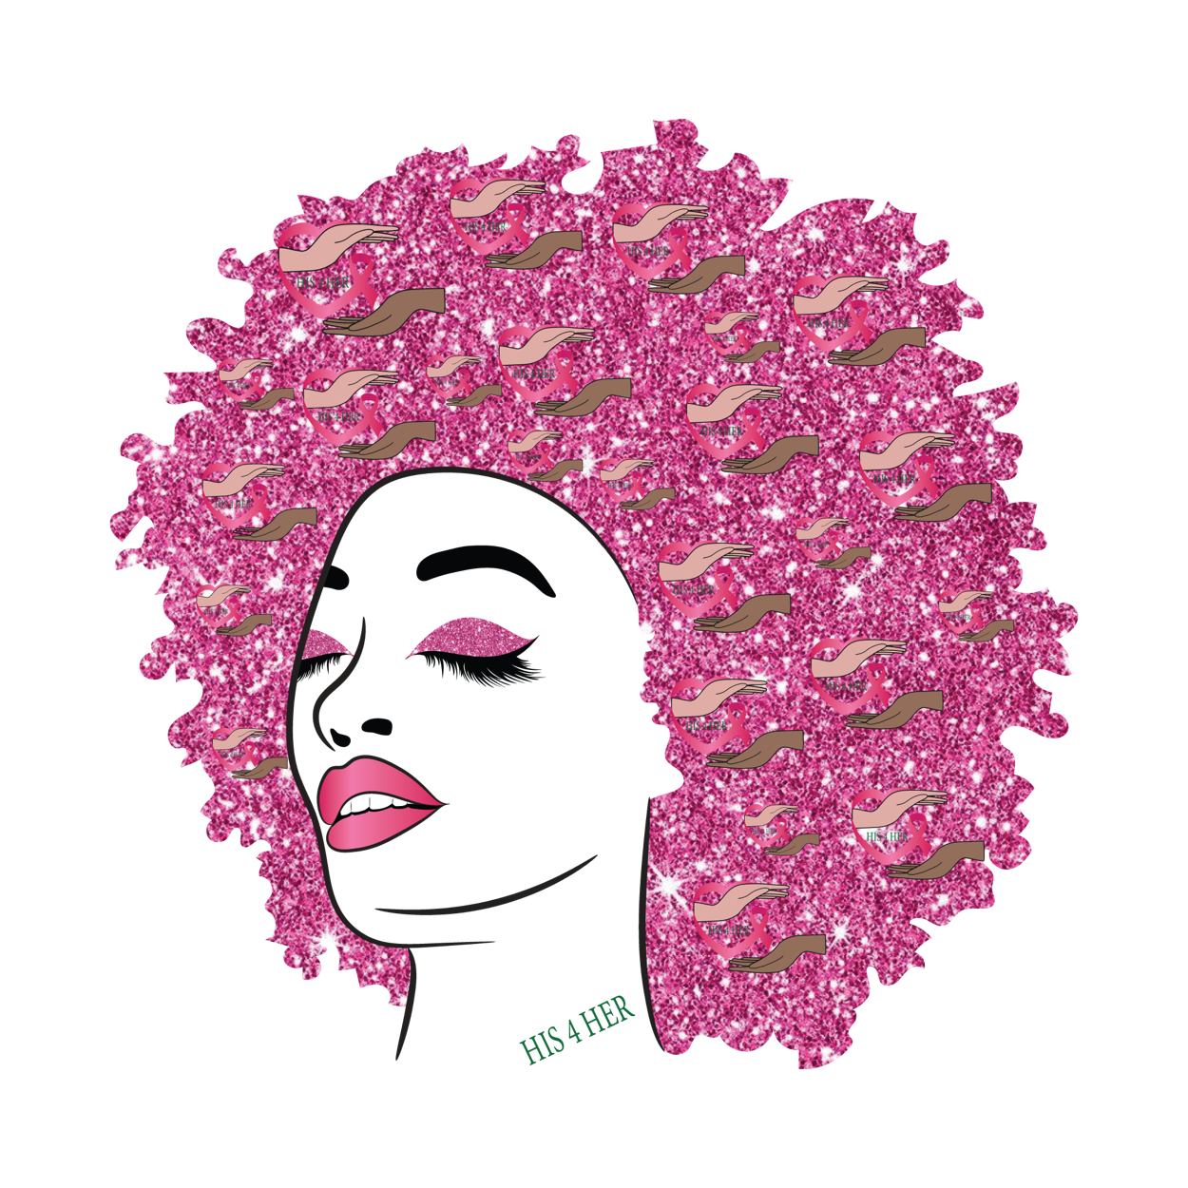  HIS4HERS  Health Information Station  1120 S. 6th Street Ste. 100  St Louis. MO 63104  314-585-2035 # 3 | Breast care education, mammogram services, safe space to express breast care concerns and resource hub.  HIS4HERS campaign not only support women but then inclusion of all people interested in breast care awareness and health.  The campaigned entails scheduled appointments that consist of education classes, clinical breast exam, mammogram, and incentives posted on Health Information Station Calendar of events. We look forward to serving our community.

